PC BUILDING GUIDE
Simple & Easy
Full Detailed Guide with Images

Preparation
- Gather all your components, the parts are;
- CPU (Processor)
- Motherboard
- RAM
- SSD
- Graphics Card
- Power Supply
- CPU Cooler
- Case
You will need some tools to assemble your PC.
These are the necessary tools ;
- Screwdriver Kit (or) One Big Philips head (+) Screwdriver and one small one (+) for the SSD.
- A Tray or box for keeping screws.
- Cable Ties for cable management.
- Wire cutter or Cutting pliers for cutting the cable ties.
These Tools are necessary and enough for building a PC.

PC Building isn’t hard as you think, even if you have different parts, the PC Building process is the same for all.
This Guide includes specific process for each and every part and differences.

The PC Building process is divided into 3 Phases or Parts.
- Motherboard Prep (Phase 1)
- Power Supply Prep (Phase 2)
- The Assembly and Cable Management (Phase 3)

Phase 1
The Motherboard Preparation
This phase ensures the board is fully prepped before it goes into the case.

CPU Installation
- Unbox the Motherboard, place the motherboard on top of the box that you unboxed.
- Unbox your processor (CPU), unlock the retention pin on your motherboard, open the CPU shield.
- Hold your CPU by the sides, “Don’t touch the bottom or top!”, look for the triangle on your CPU and your motherboard, align the CPU with the triangle in direction of the motherboard’s triangle.
- Carefully place the CPU on the socket, don’t force or push it.
- Ensure it is fit by checking from the side, if not try moving side to side gently.
- Once fit, close the CPU shield, lock the retention pin, The CPU plastic cover will pop, if it didn’t pop out, take it out by hand, keep it safe in the motherboard’s box, You will need it later in the future.
- The CPU installation is done. Congrats!

RAM Installation
- To install the RAM, there will be 2 or 4 RAM Slots (Depending on your Motherboard).
- This guide will cover any number of RAM stick installation for both 2 and 4 slot motherboards.
- For 1 Stick of RAM;
- For 2 Slot Motherboard : Unlock the RAM Holder or Clip on the first slot. Align the RAM with the Notch on the slot, Press the RAM down firmly until it clicks.
- For 4 Slot Motherboard : Unlock the RAM Holder or Clip on the second slot. Align the RAM with the Notch on the slot, Press the RAM down firmly until it clicks.
- For 2 Sticks of RAM;
- For 2 Slot Motherboard : Unlock the RAM Holder or Clip on both slots. Align the RAM with the Notch on the slots, Press the RAM down firmly until it clicks.
- For 4 Slot Motherboard : Unlock the RAM Holder or Clip on 2nd and 4th slot. Align the RAM with the Notch on the slots, Press the RAM down firmly until it clicks.
- For 4 Sticks of RAM;
- For 4 Slot Motherboard : Unlock the RAM Holder or Clip on all slots. Align the RAM with the Notch on the slots, Press the RAM down firmly until it clicks.
- RAM Installation done.

SSD Installation
- For the M.2 NVME SSD;
- Locate the topmost NVME Slot in the motherboard for installing your primary SSD (because those slots are the closest to your CPU and the fastest, check the Motherboard manual for the PCIE Generation and speed support)
- Most Modern motherboards include M.2 Heatsink, you will need to remove it by unscrewing it.
- Once the heatsink is removed, locate the slot and install your SSD into the slot.
- If your heatsink and SSD have separate screw holes, then screw the SSD into place. If it doesn’t just leave it and continue to next step.
- Under your heatsink you will find a thermal pad (which dissipates the heat from SSD to Heatsink), there will be a plastic cover on it, remove it.
- Once removed align the heatsink and screw it down, this will secure the SSD.
- If you don’t have a motherboard with heatsink, just install the SSD, screw it down, that’s all.
- SSD Installation done.

- If you have any SATA SSDs or Hard Disks to install, the guide for it is in the last. (You will need to install your power supply and do the next steps, then only install your HDDs or Sata SSDs).

Phase 1 Done.

Phase 2
Case & Power Supply Preparation

- Unbox the case, unscrew the side panels and remove them, keep them in the cardboard box that you unboxed.
- Unbox your Power Supply (PSU)
- If it is a Modular PSU (The PSU with Detachable Cables), plug in the cables that you only need, keep the remaining cables in the box.
- If it is a non modular PSU (PSU without detachable cables), continue to next step.
- Place the PSU inside the Case with the FAN Direction facing down.
- Align the PSU with the holes on the case.
- Screw in the PSU in zig zag direction into the PSU for even tightness.

Phase 2 Done.

Phase 3
Assembly and Cable Management.

All PC Building Screws
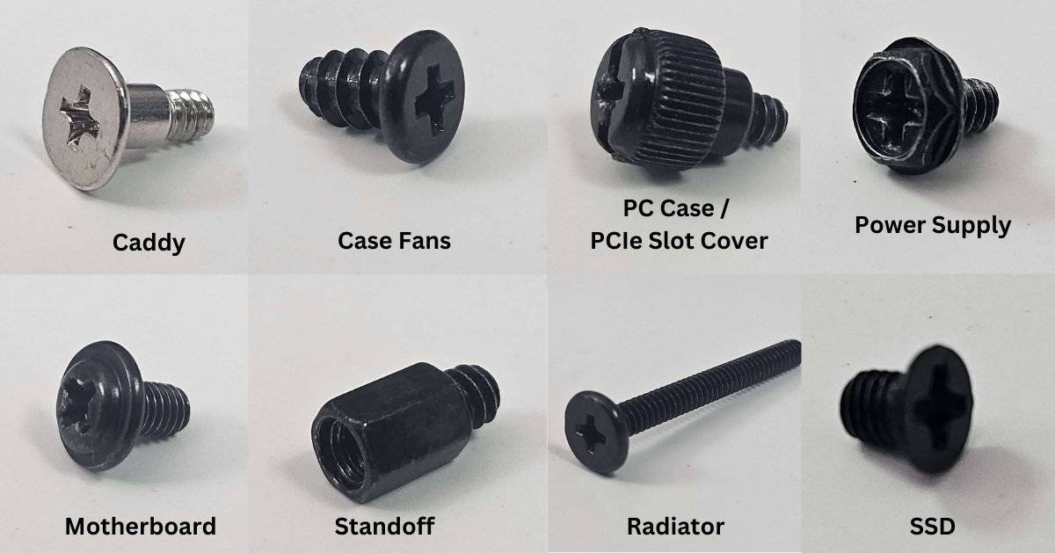
- Before the next steps, if you have an Air Cooler install it now, the guide is in the end. If you have AIO liquid cooler, just install the backplate or any accessories now, install the AIO after the next steps, The Guide is also in the end.
- Take the Prepared Motherboard, locate the standoffs on the case, align the Motherboard holes with the standoffs on the case, if standoffs are missing, install them (They are included in the case box).
- Once installed, take the motherboard screws (Included in the case box), screw the motherboard into the case.
- Plug in your motherboard cables;
- 24 (20+4) Pin ATX Motherboard Cable, connect it into the motherboard’s 24 PIN ATX Slot (right of motherboard).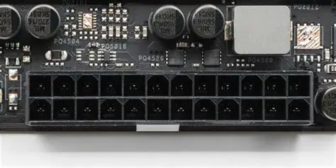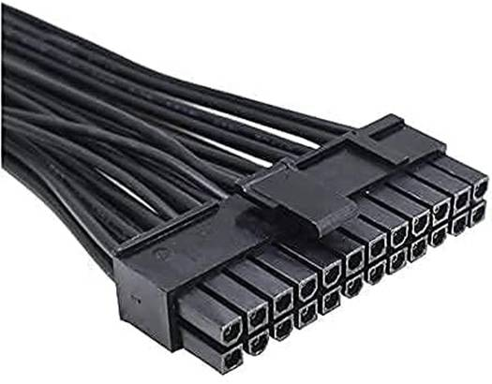
- 8 (4+4) Pin CPU EPS Cable, connect it into the motherboard’s 8 Pin CPU Power Slot, (on top of the motherboard).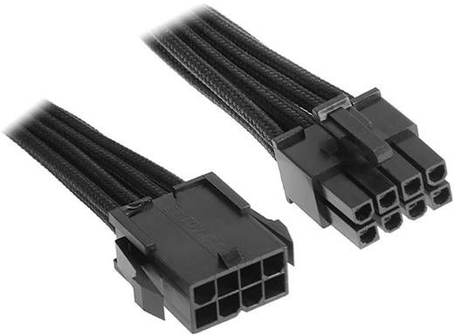
- Once Plugged in, plug in the Front Panel cables into the motherboard.
- HD Audio Connector & Header.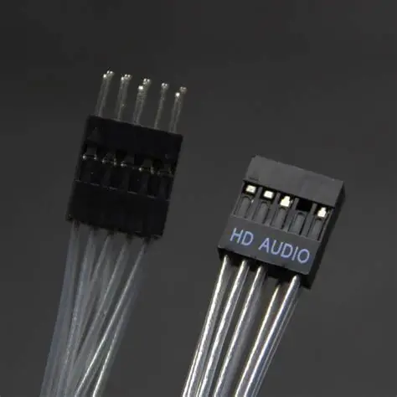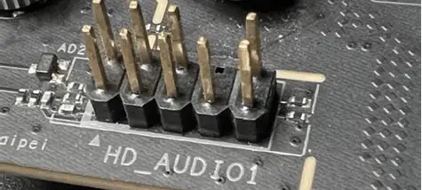

- USB 2.0 Connector & Header.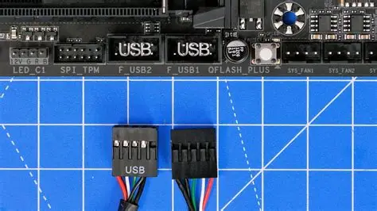

- USB 3.0 Connector & Header.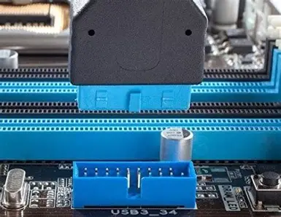
- USB C Connector & Header. (if your case has one, if it doesn’t have this, then leave it).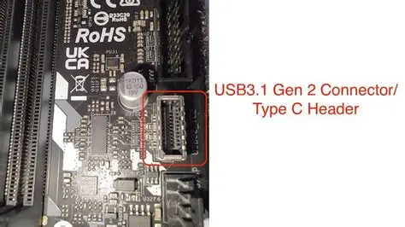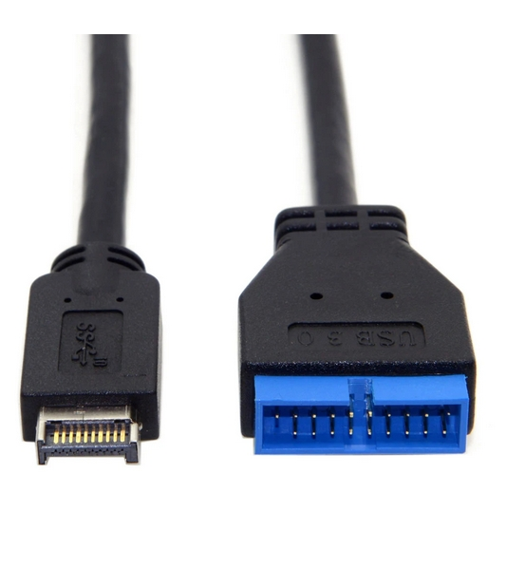

- Front Panel Connectors & Headers, They either come as one single connector or separate small connectors.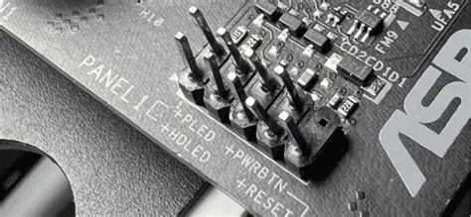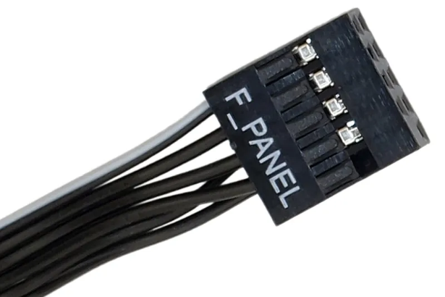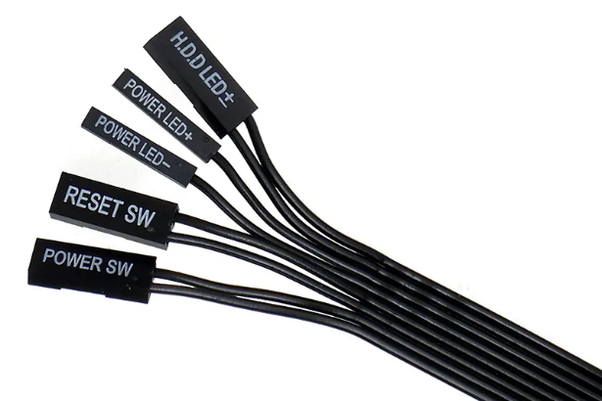

- The Cable connection to motherboard is done.

CPU Cooler installation

For Air Cooler;
- If the CPU Come with included stock cooler, you don’t need to buy a CPU Cooler.
- If the CPU didn’t come with one, you will need to buy a CPU Cooler, for higher end and hot CPUs, buy an AIO Liquid Cooler instead.
- But anyways all AIR Cooler installation is the same.
- For Stock coolers;
- AMD Wraith Stealth Cooler (AM4/AM5)
- It comes with Pre-Applied thermal paste, so you don’t need to apply manually.
- The Cooler is always inside the CPU Box.
- You don’t need to remove the mounting bracket or screws for this cooler.
- Align the Cooler over CPU Socket.
- Tighten the Screws in a cross pattern.
- Don’t overtighten.
- Connect the FAN Cable from the Cooler to the CPU_FAN Header in the top of the motherboard.
- Done.

- AMD Wraith Prism Cooler (AM4/AM5)

- It is an RGB Cooler.

- Pre-Applied Thermal Paste.

- The Cooler comes in two types, Screw-Type and Clip-Type.

- For Clip-Type, Align the cooler over the CPU.

- Hook the one side to the mounting retention brackets.

- Then press and latch the other.

- For Screw-Type, it requires the metal backplate that is given, remove the plastic retention bracketsAlign the cooler over the CPU and Tighten in cross pattern.

- Connect fan cable to CPU_FAN Header.

- Intel Stock Cooler (LGA 1700)

- It is a Push-Pin cooler with pre-applied thermal paste.

- Align the cooler over CPU.

- Push each pin down firmly. Do this in cross pattern for even pressure, You’ll hear a click when each pin locks.

- Check that all pins are locked by flipping the motherboard and verifying the black pins are through the white anchors in the back.

- Connect fan cable to CPU_FAN Header.

Stock Cooler installation done.

For Aftermarket Coolers, follow the instructions on the manual that’s given, they have every single information. All aftermarket coolers have slightly different brackets and installation steps. So follow the manual.
For AIO Liquid Cooler;
- While we were preparing the motherboard, we installed the backplate that came with the AIO Liquid Cooler.
- Now we need to install the cooler.
- Radiator placement.
- You need to figure out where to put the radiator, it depends on the case.
- Usually the Top is the best, in some cases there are side mounts in panoramic view cases, it depends upon the case. But the top is the recommended.
- For Top, keep the fan in exhaust direction. (recommended).
- For Side, if the case supports it, keep the fan as intake.
- If the Fans on the radiator doesn’t come pre installed install them.
- If you’re installing the radiator on top, install the fans in a exhaust direction (look at the fan’s side for the airflow direction arrow). The Fan has to pull the air from the inside of the case to outside.
- Install them as exhaust, screw them with the long radiator screws.
- Once the Fans are installed (or) you have a radiator with pre-installed fans, continue.
- Mount the radiator by aligning the holes with the case bracket.
- Secure with screws (don’t overtighten them).
- CPU Pump installation.
- Apply thermal paste on the CPU (if it doesn’t come pre-applied on the pump).
- Align the pump with the backplate holes.
- Lower evenly onto the CPU.
- Tighten the screws in cross pattern.
- Avoid overtightening.
- Cable Connections;
- Pump power: Connect pump cable to AIO_PUMP/PUMP/W_PUMP header.
- Radiator Fans : Connect to SYS_FAN Headers, but they come with daisy chaining (connecting multiple fans together) by connecting the connectors each other and connecting the last one to the SYS_FAN Header, or use splitter or hub to connect them.
- RGB/ARGB (if included) : Connect to motherboard RGB header or USB header, or connect to Hub.
- USB Cable (if included) : Connect to the USB 2.0 Header on the motherboard.
AIO Liquid Cooler installation done.

Graphics Card Installation;
- If you have a Graphics card, continue. If you don’t have or you didn’t buy, make sure your processor has integrated graphics.
- Align the GPU into the top PCIE x16 Slot located on the motherboard.
- Check how what PCIE Covers to remove.
- Remove them by unscrewing or if your case has breakeable covers, remove it by wiggling side to side.
- Once removed, align your GPU into the top PCIE x16 Slot, Press it Gently and once clicked in, Screw it down on the PCIE Bracket.
- Connect the GPU Power Cable;
- If your GPU is a standard GPU, you will need 8 (6+2) PIN PCIE Cable from the Power supply.
- Connect it to your GPU, some GPUs require more than 1.
- If your GPU requires the 12VHPWR Connector 12 Pin connector, you will need a power supply that is rated ATX 3.0+, if your power supply doesn’t have any 12 Pin Connector, you will need to use the 2x8 Pin to 12 Pin Splitter. Connect it to your GPU, some GPUs require more than 1 12VHPWR Connector.
- GPU Installation Done.

Cable Management;
Cable Management is just tidying up your cable mess.
You will need some cable ties or Velcro, a wire cutter for cutting the cable ties, that’s all.
If you have unused cables or extra cables, hide them.
If more than one cables are going in a same path, tie them using the cable ties, cut the excess.
That’s all the cable management, now close all the panels, screw the side panels and that’s all, PC Complete.

The PC is Complete.

Now you need to connect your monitor, keyboard, mouse and other peripherals to your PC. (Connect the HDMI/DP Cable from your monitor into the Graphics card (if you have one), if you don’t have it, connect into the motherboard).

OS Installation
OS installation is pretty simple, all you need is a pendrive with atleast 8gb of Storage. Backup any data that you have in the Pendrive because the drive will be formatted to install the OS.
If you have another PC or laptop, plug in the pendrive into it, install the windows media creation tool from their Microsoft website for windows 11. Use that app to choose your pendrive, click on install and wait until it gets formatted and gets ready. If you want a different option, then install rufus app on the other PC/Laptop,
Install the Windows 11 ISO file from the website, then in rufus app, choose the ISO you downloaded, select the pendrive, click on Install, it will get formatted and get ready for OS installation.

If you don’t have another PC/Laptop or you can’t borrow one, you can do this in your mobile or android device, Download the Win 11 ISO file from the Microsoft website, Download ISO 2 USB from Google Play, Connect the Pendrive to your Mobile using OTG adapter, Select the windows ISO File, choose the USB Drive as target. Tap on Write, wait until the flashing completes. Safely eject by ejecting the pendrive in file explorer or notification.

Now after the Pendrive is ready, lets start installing the OS, plug in the pendrive, Turn on your PC, once booted you will be inside the BIOS, search for boot options or boot menu, click on it, there click on the USB Pendrive, the PC will restart, if it doesn’t, save the BIOS settings and restart, Once booted back, you will be asked your OS language, Time and currency format, Keyboard or input method. Change them as you need then click Next, then Install Now. Accept the Microsoft Software License Terms, Click next. Select Custom: Install Windows only (advanced), this option lets you perform a clean install rather than upgrading (which you cant do with a new ssd, because there is no OS already), You’ll see a list of available drives/partitions, For a fresh install, delete any existing partitions on the target drive (This erases data, but if the SSD is now then continue to next step), select the unallocated space, click next.
Windows will now copy files, install features and configure updates, this step is automatic and may take more than 5-20 Mins depending on you PC hardware.
The PC will restart several times ( don’t remove the USB until the setup is complete and your OS is installed).
After installation, you’ll be guided through;
- Region and keyboard layout selection
- Network setup
- Microsoft account (or) Local account (to know how to create follow the guide)
- Privacy settings
- PC name and option PIN/Password Setup.
To create a local account (which is recommended), click on the “I Don’t have Internet” option during the Network setup, if you don’t see this option, press Shift+F10 to open command prompt, type this command : OOBE\BYPASSNRO
Press enter, the system will reboot automatically.
Once booted back, the you’ll be in the setup again, now click on “I Don’t have internet” that should appear, Select it, continue with limited setup. You’ll be prompted to enter a username and optionally a password. This creates a local account without requiring a Microsoft account or internet connection.
Finish the setup through the other region, keyboard, privacy settings .etc, You’ll land on the windows desktop with a local account. Your PC is finished and booted into Windows, Congrats!

Now you need to do a few things before you start enjoy using your PC. (this is a must)
- Install your GPU drivers, If you have NVIDIA GPU, type NVIDIA drivers in the browser, you’ll see the official NVIDIA website first, click on it, you’ll see manual driver search first, there first click on Product category, choose your graphics card (most of the time GeForce, if you bought any workstation Quadro card, select that instead) click on your series, e.g : 50 series, 40 series .etc, then click on the product, select the card that you bought, select your operating system and language that’s all. Click on Find, you’ll be presented with Game Ready Driver and Studio Driver, if you’re a gamer, choose Game Ready Driver, if you’re a video editor or productivity, choose studio driver. If you do both, then you can choose either but game ready drivers are better. Once the file downloads, click on it, the installer will open, then accept the NVIDIA software license agreement, click next, choose between Express or Custom, if you want a clean install, select Custom > Perform a clean installation. Then the installation will start, the screen may flicker sometimes or go black briefly that’s normal, wait until the process completes.
Once finished, you’ll see installation complete.
Click close, restart your PC.

This process is the same for all AMD and Intel GPUs, you just need to go to their website.

Then you need to install your WIFI drivers if you have from the wifi adapter manufacturers websites.

That’s all the PC is complete and ready to use.

Enjoy your PC Building Journey.

